Angular Installation

Before to setup environment for Angular development using the Angular CLI tool, you must have installed Node.js on your system and set a development environment and npm package manager.

Install Node.js

Angular requires Node.js version 10.9.0 or later. You can download it from <https://nodejs.org/en/>

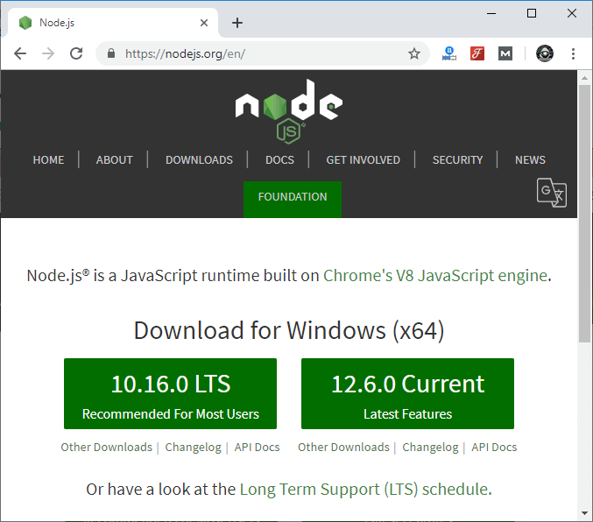

After downloading, you have to install it on your system.

Competitive questions on Structures in HindiKeep Watching

See how to install Node.js on Windows: [**Click Here**](https://www.javatpoint.com/install-nodejs)

See how to install Node.js on Linux/ Ubuntu/ CentOS: [**Click Here**](https://www.javatpoint.com/install-nodejs-on-linux-ubuntu-centos)

Once you have installed Node.js on your system, open node.js command prompt.

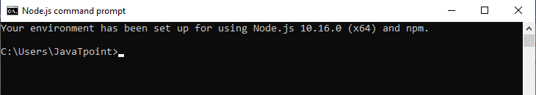

* To check your version, run **node -v** in a terminal/console window.

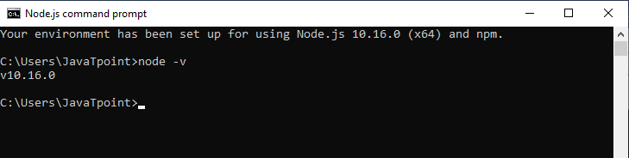

Use npm to Install Angular CLI

Use the following command to install Angular CLI

1. npm install -g @angular/cli

Or

1. npm install -g @angular/cli@latest

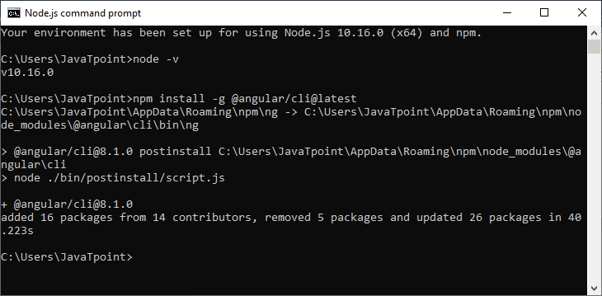

Or

Just go to Angular CLI official website <https://cli.angular.io/>

You will see the whole cli command to create an Angular app. You need to run the first command to install Angular CLI. These steps are same for Windows and Mac.

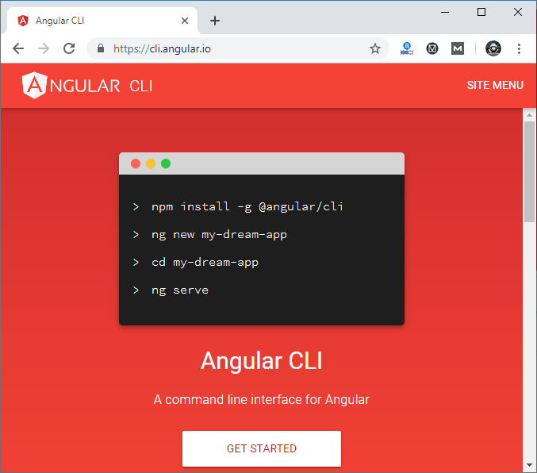

Check your Installed versions

* To check Node and Angular CLI version, use ng --version command.

